Task 1 — Enable Azure Monitor (4 Marks)
Task 1.1 — Enable Monitoring on Your Virtual Machine (2 Marks)
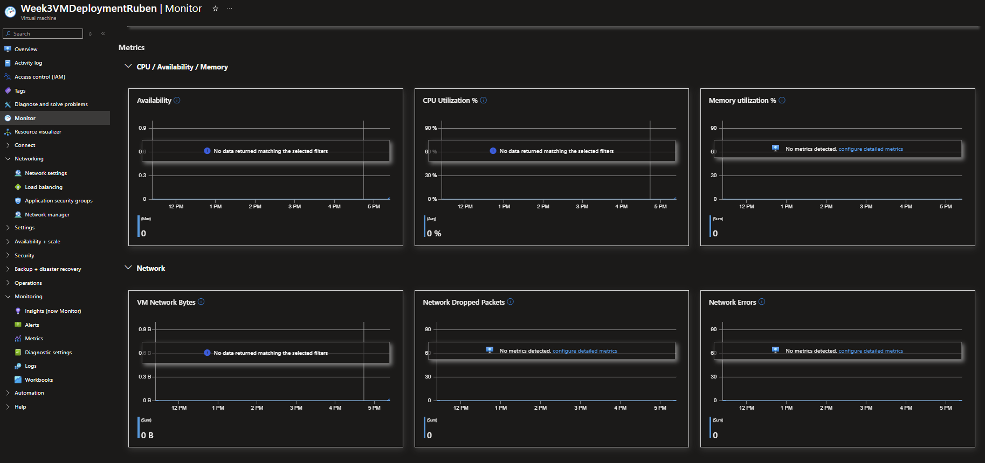
This is where the general monitoring can be seen for the virtual machine there is no network traffic being shown because the VM is not on.
Task 1.2 — Enable Monitoring on Network Resources (2 Marks)
VNET
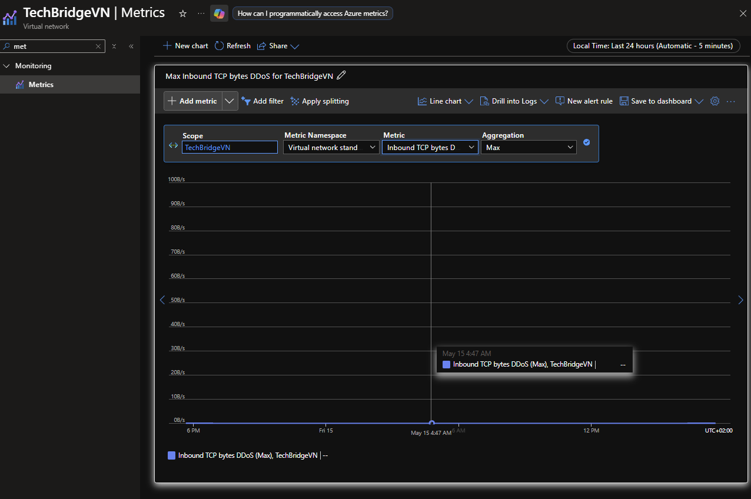

NSG
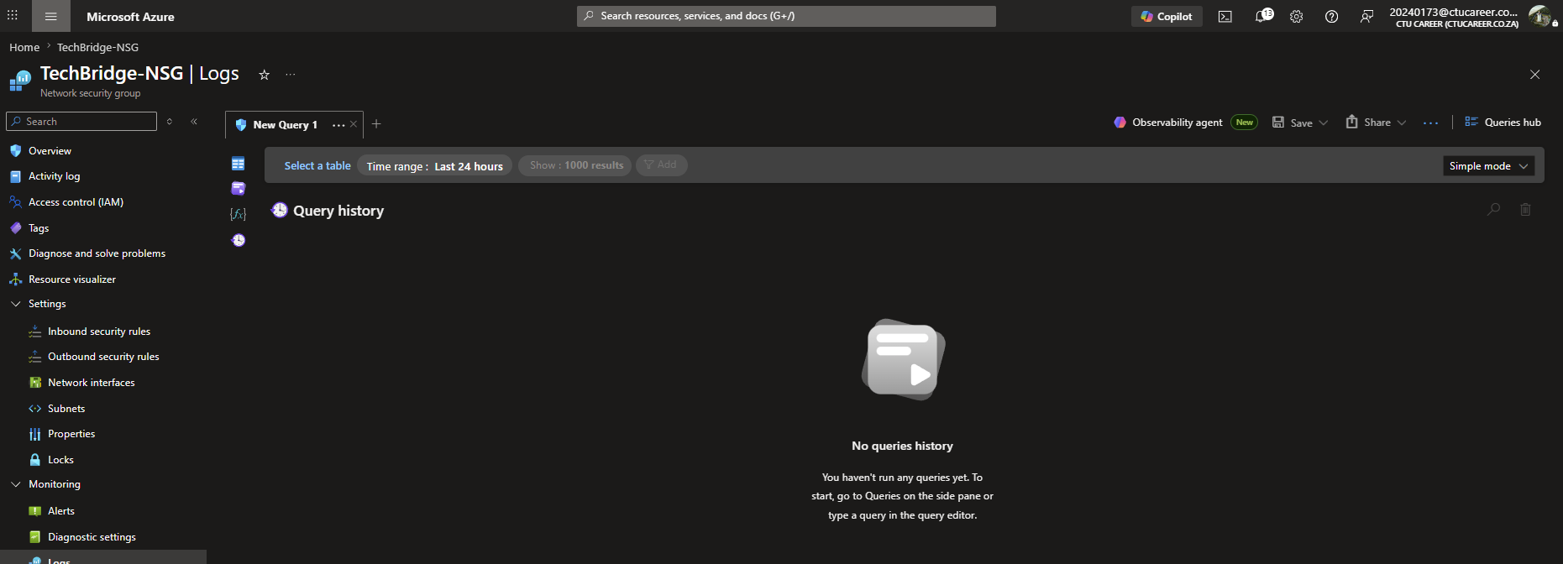
Task 2 — Review Key Metrics (3 Marks)
Task 2.1 — CPU Metrics
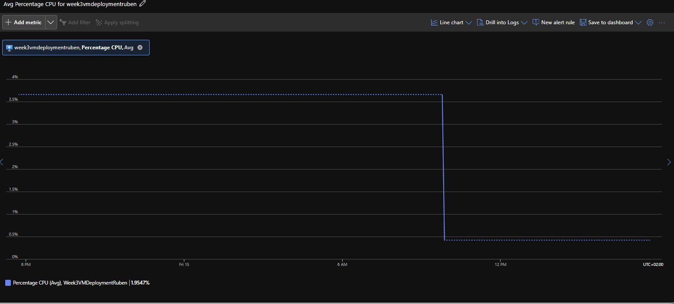
Task 2.2 — Network Metrics
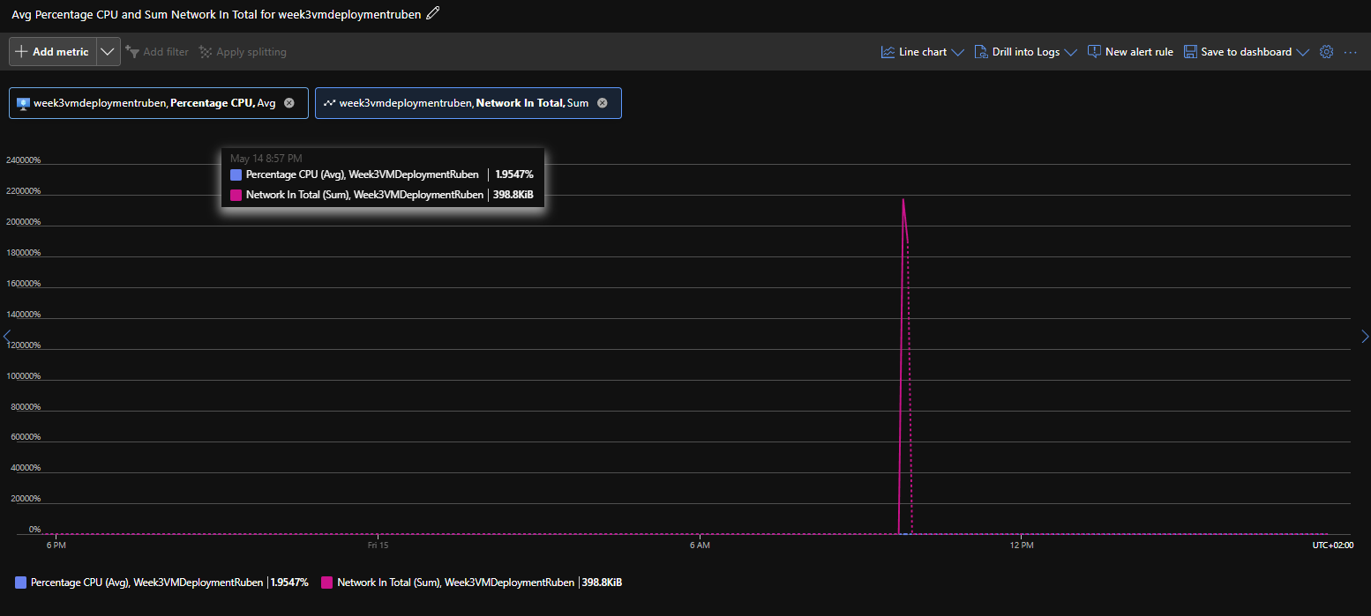

Task 2.3 — Disk Metrics
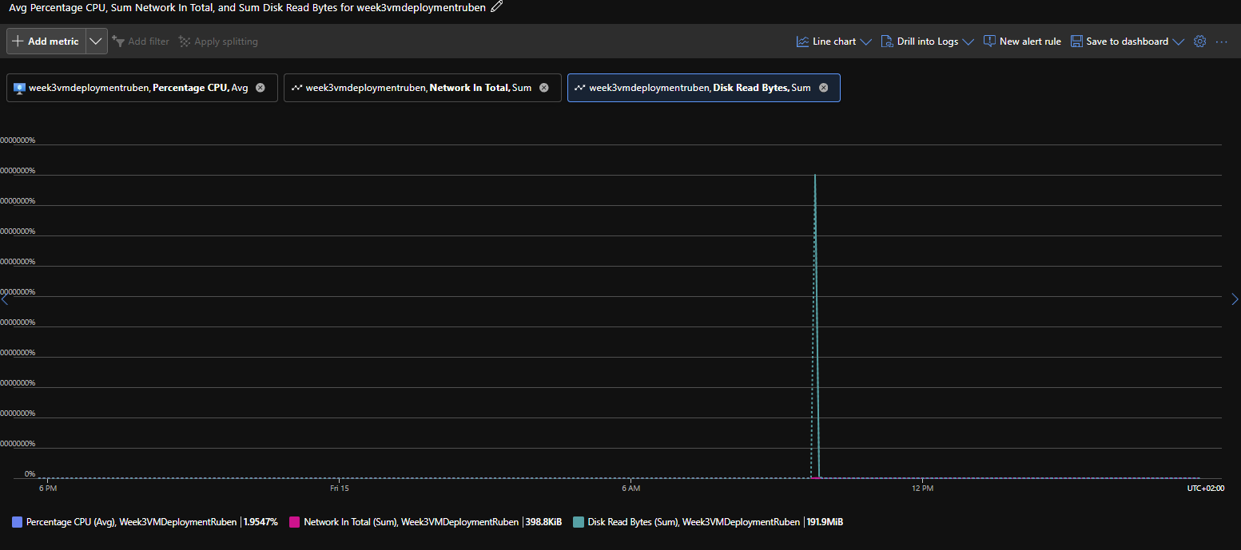
Task 3.1 — Monitoring Summary (2 Marks)
Resources Monitored: I enabled monitoring on the Virtual Machine to track key performance metrics, including CPU usage, disk activity, and network traffic using Azure Monitor. I also configured diagnostic settings on the Virtual Network (VNet) and Network Security Group (NSG) to collect relevant metrics and logs.
Metric Observations: The collected metrics appeared normal for the current workload. However, due to the short period since enabling monitoring, only limited data was available for analysis.

Task 3.2 — Extension: Configure an Alert Rule (1 Bonus Mark)
